**Aggregate Queries**

**1.Query for showing orders with highest amounts skipping the first highest one  
  
Query:**

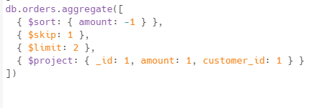

**2.Query for finding first order data and last order date of each customer**

**Query:**

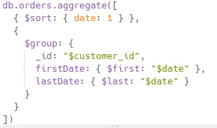

**3.sorting the products by highest order count**

**Query:**

**three.PNG**

**4.Query for calculating orders based on the city**

**Query:**

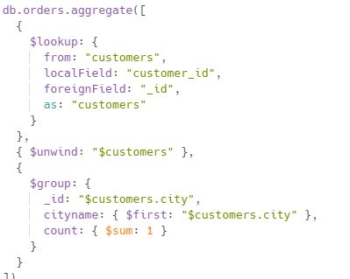

**5.Query for calculating totalamount,average amount and number of orders for each customer**

**Query:**

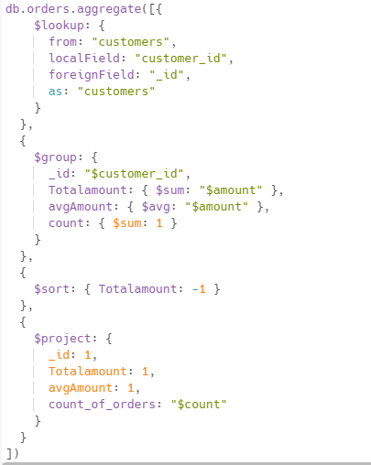

6.Caluclating total amount for shipped orders for each customer

Query:

